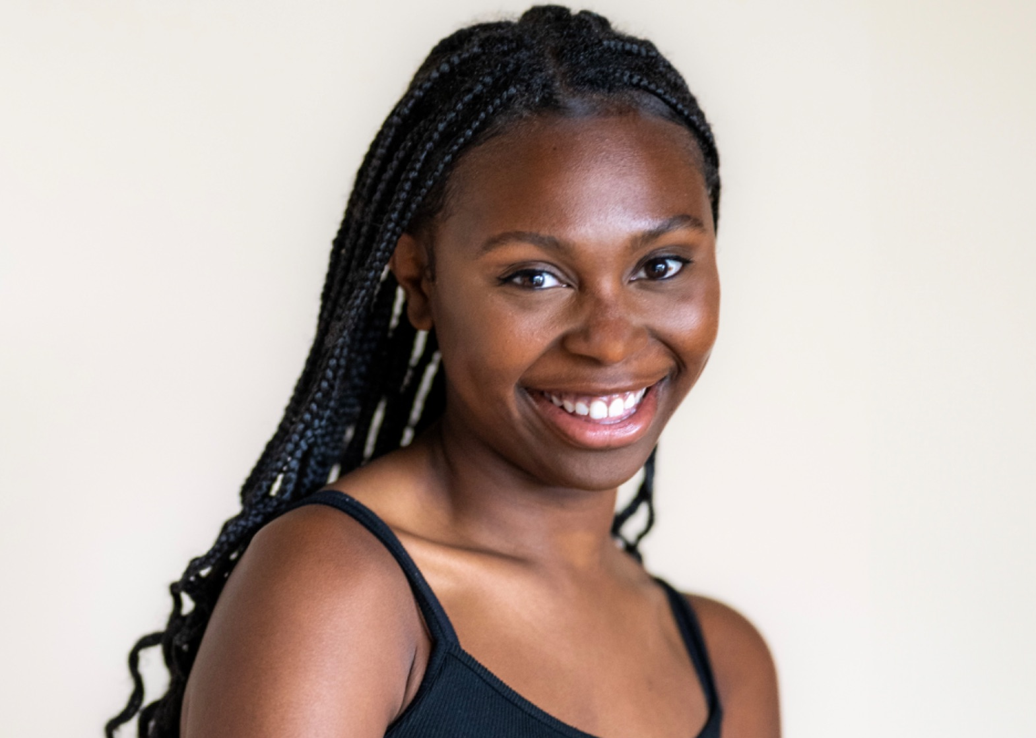
rose.c.artist@gmail.com | Height: 5’ 2” | Vocal Range: E2-D5 ; Belt to G4

Theatre

Proof | Catherine | Santa Cruz Shakes dir. Rebecca Haley Clark
As You Like It | Phoebe/First Lord | Santa Cruz Shakes dir. Carey Perloff
Hamlet | Player/Sailor | Santa Cruz Shakes dir. Susan Dalian
Fairview | Keisha | UNCSA dir. Jackie Alexander
Natasha, Pierre, and The Great Comet of 1812 | Heléne | UNCSA dir. Quin Gordon
The Violet Sisters | Sam | UNCSA dir. Breylyn Brown
John Proctor is the Villain | Nell | UNCSA dir. Mya Brown
As You Like It: The Musical | Mama Corin et. al | UNCSA dir. Andy Paris

Film

Bike | Supporting | Bull City Productions Dir. Jaylon Steverson
All In | Lead | UNCSA dir. Andrew Parkerton
Sunday | Dancer | UNCSA dir. Bailey James

Other Projects

“Loving This Year” Concept Album | Composer, Vocal Arranger, Producer | 2025
“Loving This Year” Live Workshop | Composer, Writer, Director, Producer | 2025
“Loving This Year” Live Reading | Composer, Writer, Director, Producer | 2023

Education

University of North Carolina School of the Arts - Expected May 2025
BFA in Drama, Worked under: Bob Krakower, Heidi Marshall, Scott Zigler, John Langs

Awards and Achievements

UNCSA Semans Art Fund Grant Recipient - 2024
Andrew Lloyd Webber Initiative Scholarship Recipient (The American Theatre Wing) - 2021
YoungArts Finalist in Spoken Theatre - 2021
Musical Theatre Songwriting Challenge Winner (The American Theatre Wing and the NEA) - 2020

Special Skills

Piano, Music Composition, Vocal Arrangement, Intermediate Dance, SAFD Certification (Unarmed and Knife, Single Sword), Conversational Spanish, Fluent IPA - Dialects upon request, Valid Driver’s License, Valid US Passport, Teaching Artist, Bahamian accent on cue.

